**Chapter 4**

**System Design**

**Chapter 1:**

**System Design**

**4.1 Introduction:**

The Bon Hotel Management System (HMS) is a modern solution designed to make hotel operations simple and efficient. It manages room bookings, meal orders, cancellations, and guest records in one digital platform. Bon HMS includes features like customized meal options, a secure login system, and subscription plans for regular guests. It also offers an interactive hotel map for easy navigation and membership programs with exclusive benefits. The system is user-friendly, accessible 24/7, and highly secure. Its goal is to save time, improve guest satisfaction, and enhance the Bon Hotel's reputation through a smooth and organized approach.

**4.2 Analysis Models**

**4.2.1 Data Flow Diagram (DFD):**

Context Diagram is another name for DFD Level 0. It's a high-level overview of the entire system or process that's being studied or modeled. It's meant to be a quick glimpse into the system, displaying it as a single high-level process with its connections to external entities.

**1.Level 0 Diagram:**

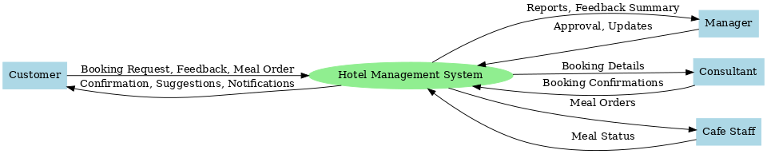

**2. Level 1 Diagram:**

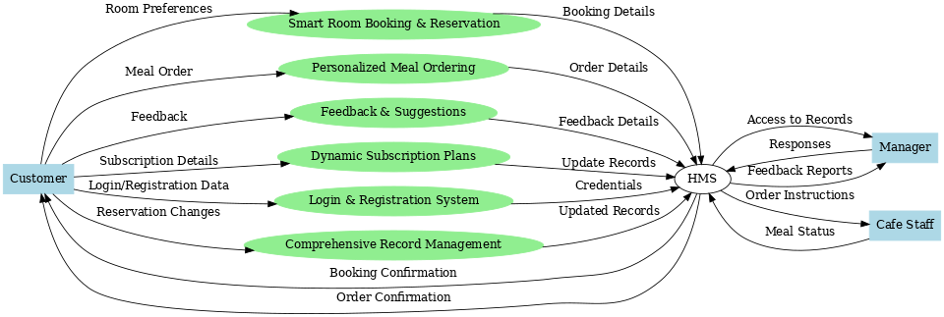

**4.3 Usecase Diagram:**

A use case diagram is a visual representation of the specifics of a system and its users. It is usually represented graphically as a picture of interactions between various parts of a system. A use case is a system analysis approach for identifying, clarifying, and organizing system needs.

**4.3.1 Usecase Diagram:**

**4.3.2 Customer Usecase Diagram**

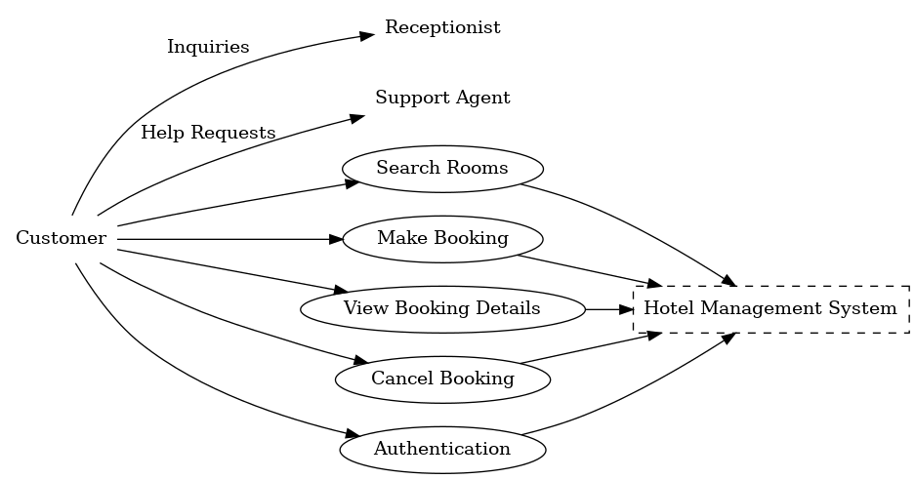

**4.3.4 Admin Usecase Diagram**

